# Problem and solution:

**1.** **Download vechile sales data -> https://github.com/shashank-mishra219/Hive-Class/blob/main/sales_order_data.csv**

**2. Store raw data into hdfs location**

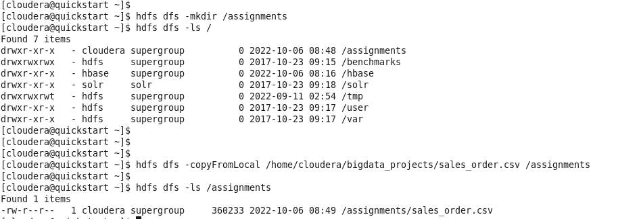

**3. Create a internal hive table "sales_order_csv" which will store csv data sales_order_csv .. make sure to skip header row while creating table**

**4. Load data from hdfs path into "sales_order_csv"**

**5. Create an internal hive table which will store data in ORC format "sales_order_orc"**

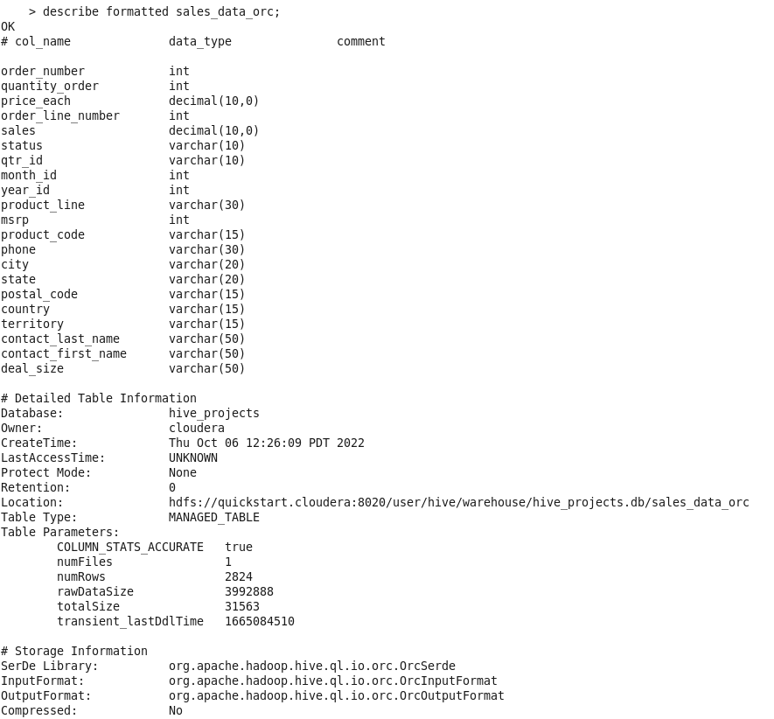

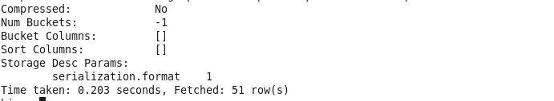

**6. Load data from "sales_order_csv" into "sales_order_orc"**

**Perform below mentioned queries on "sales_order_orc" table:**

**1)**

**Calculate total sales per year**

**HQL**

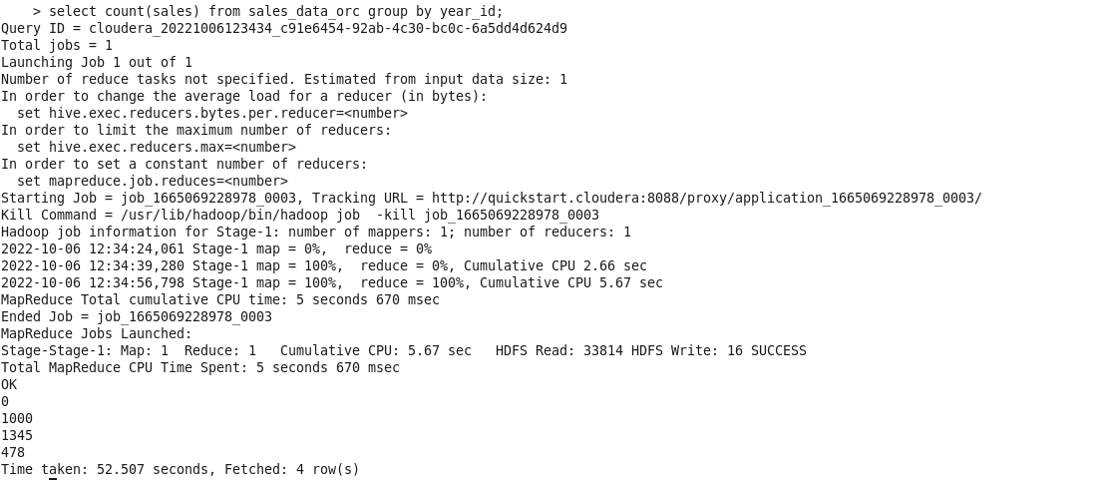

**SQL**

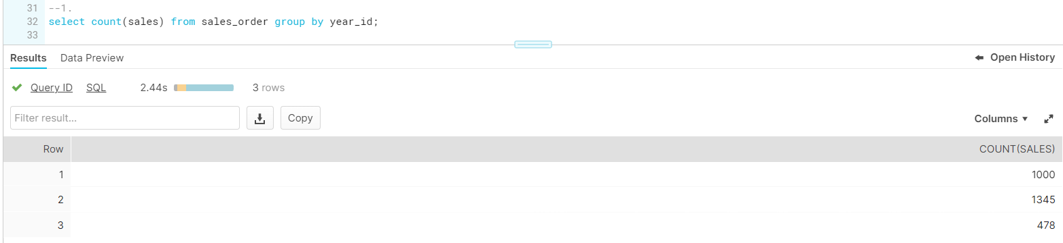

**2. Find a product for which maximum orders were placed**

**HQL**

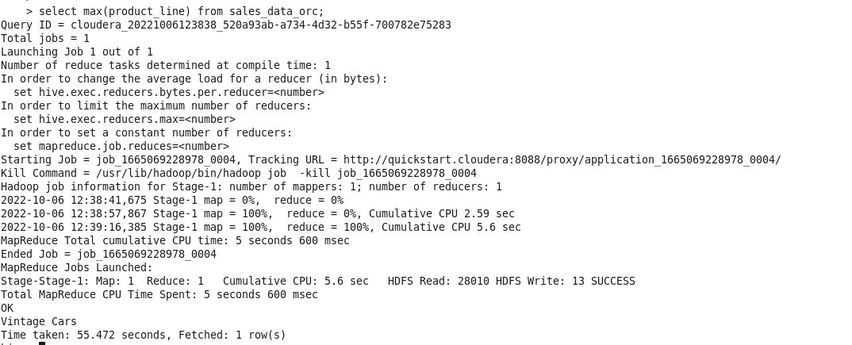

**SQL**

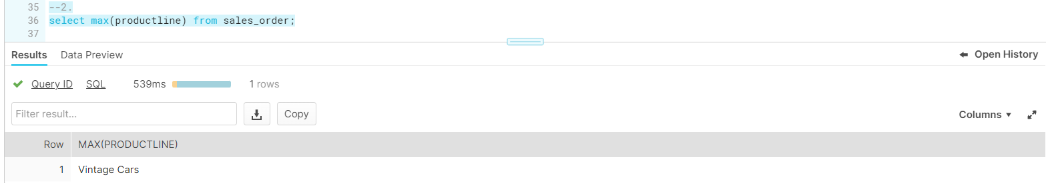

**c. Calculate the total sales for each quarter**

**HQL**

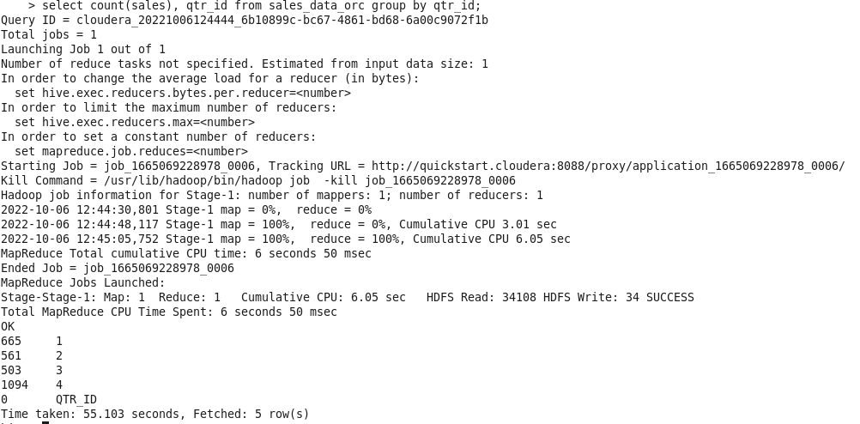

**SQL**

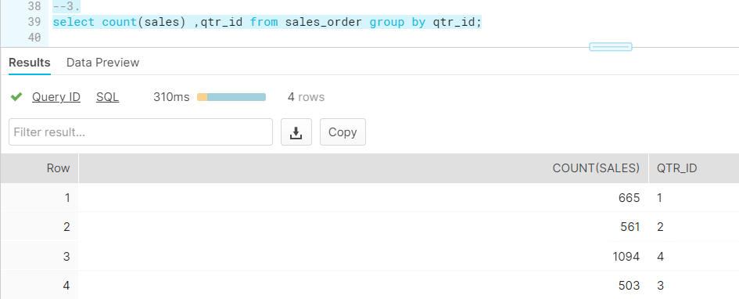

**d. In which quarter sales was minimum**

**HQL**

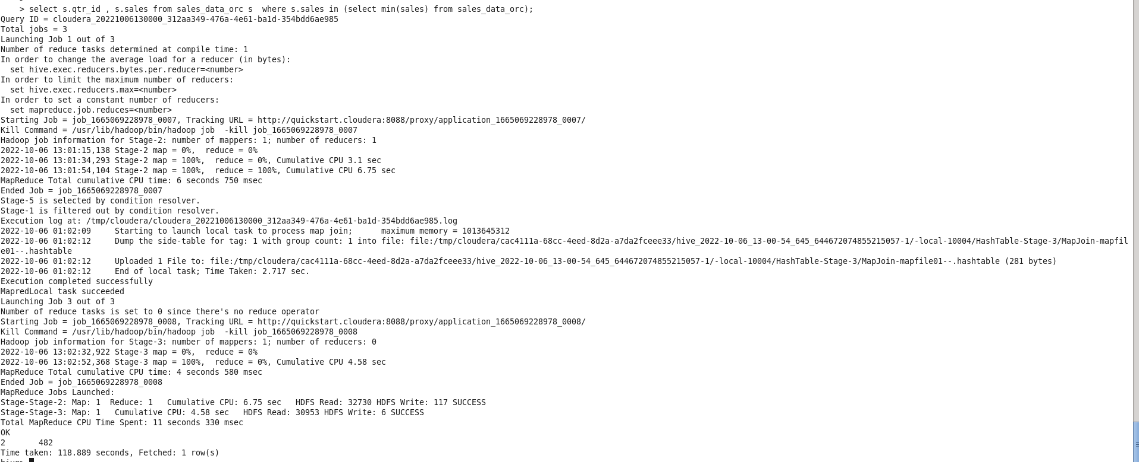

**SQL**

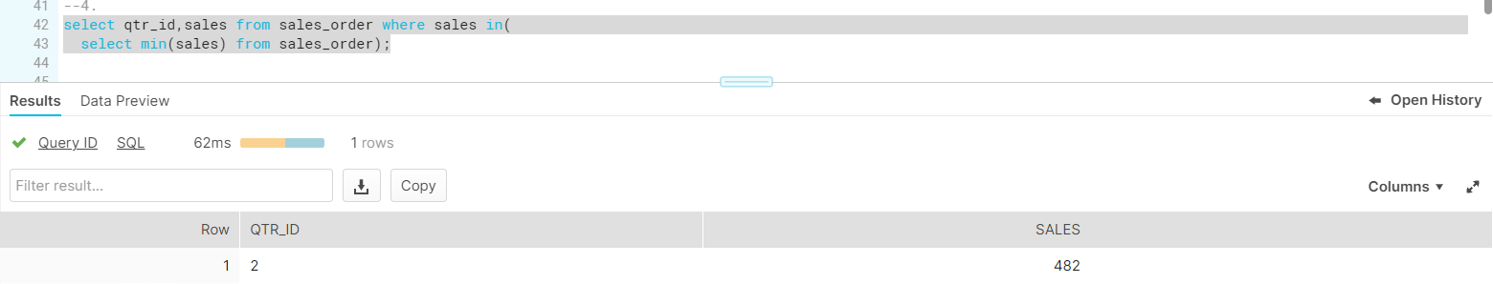

**e. In which country sales was maximum and in which country sales was minimum**

**HQL**

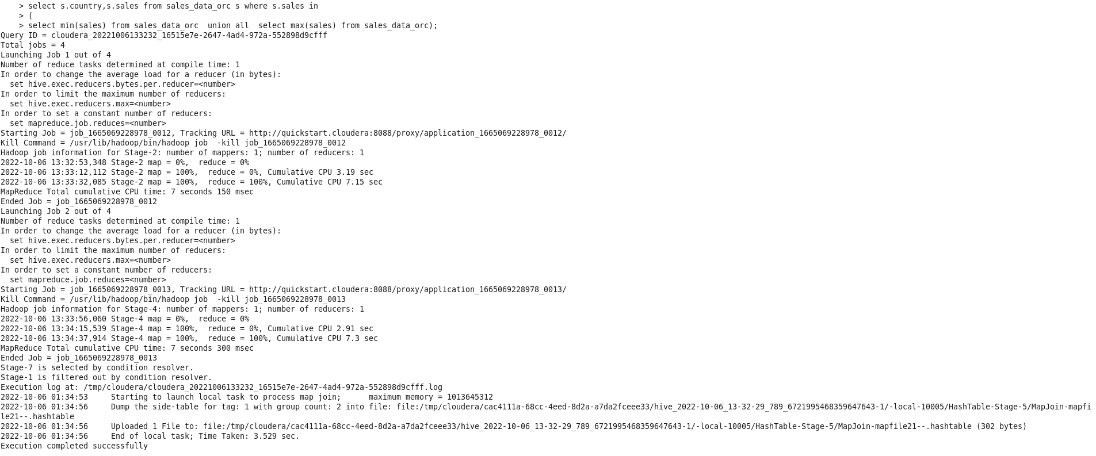

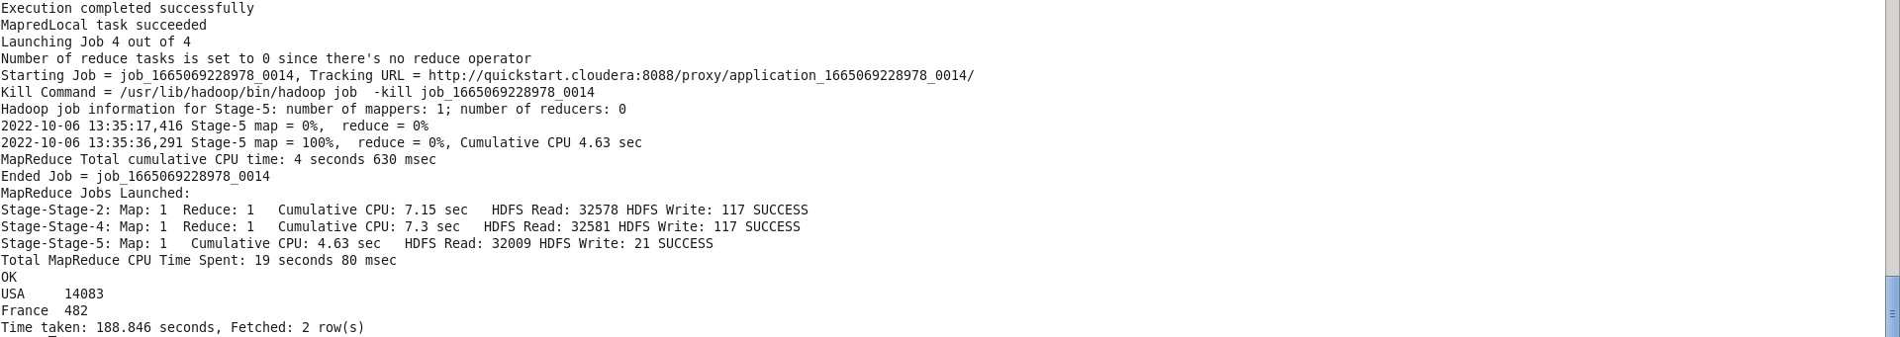

**SQL**

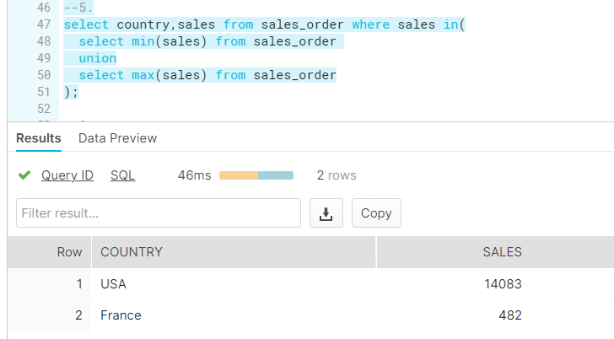

**f. Calculate quarterly sales for each city**

**HQL: Showing only few records for reference.. All the records are as per the qtr_id and naming wise**

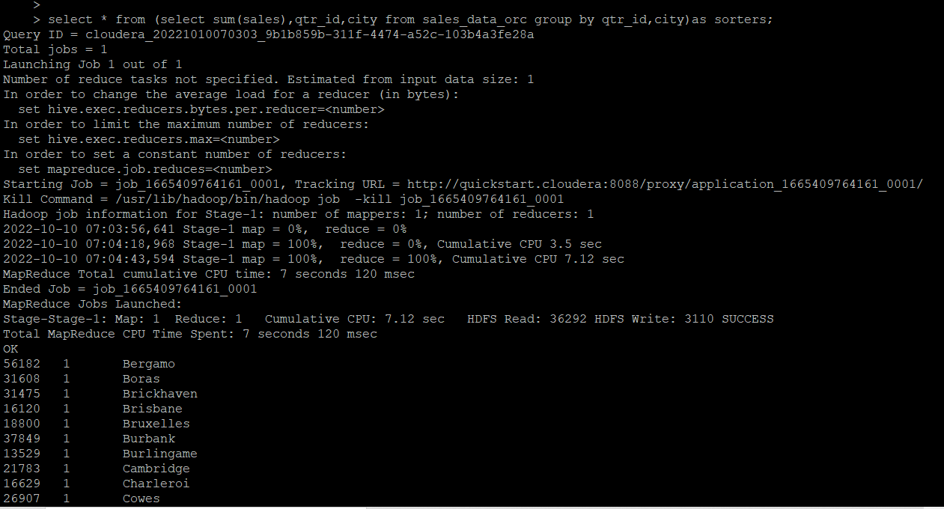

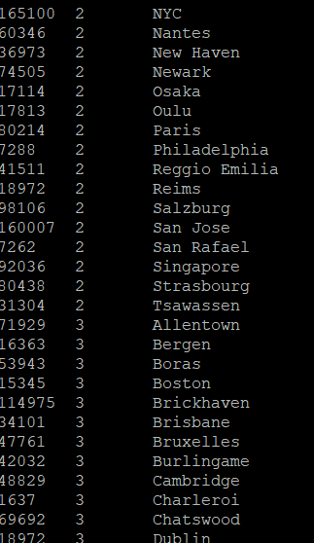

**SQL:**

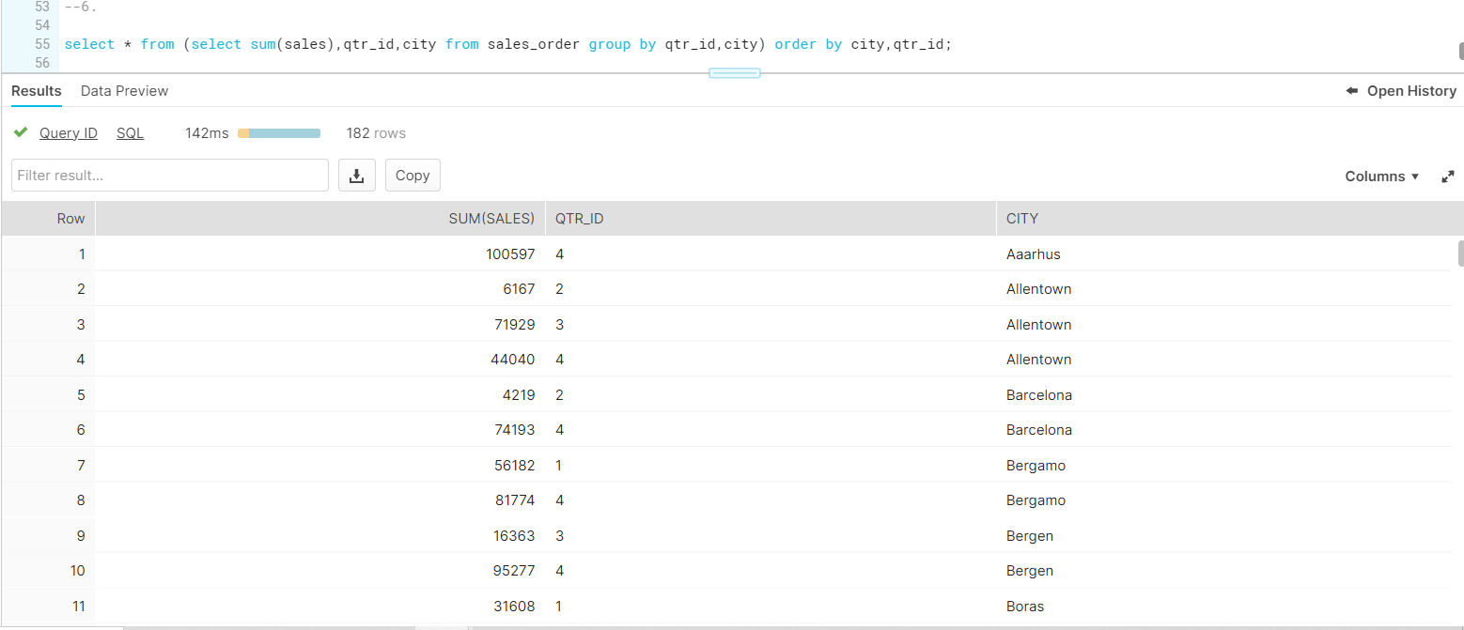

**h. Find a month for each year in which maximum number of quantities were sold**

**HQL-**

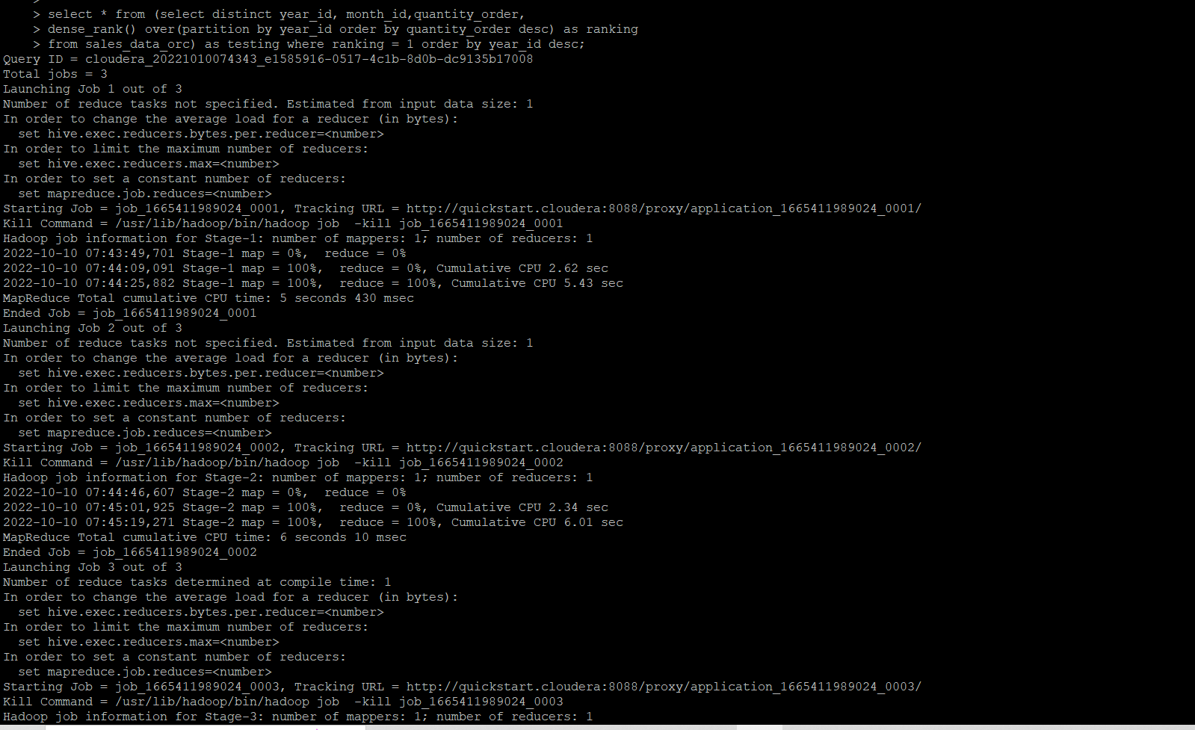

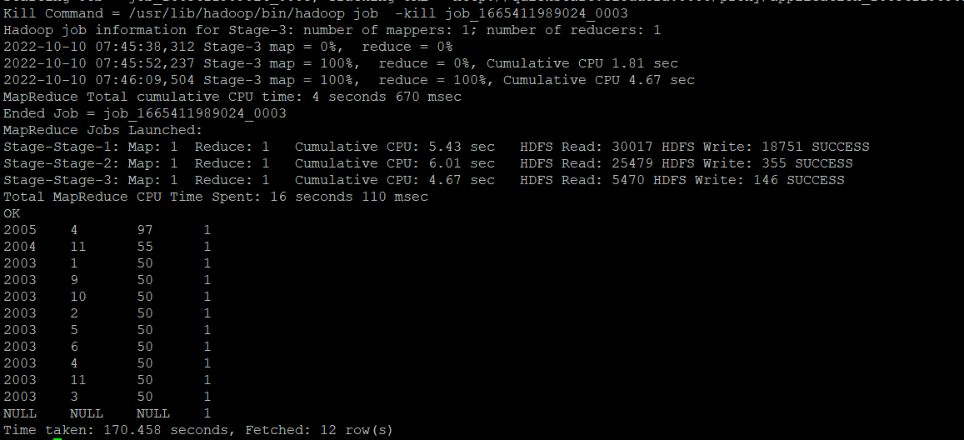

**SQL-**

